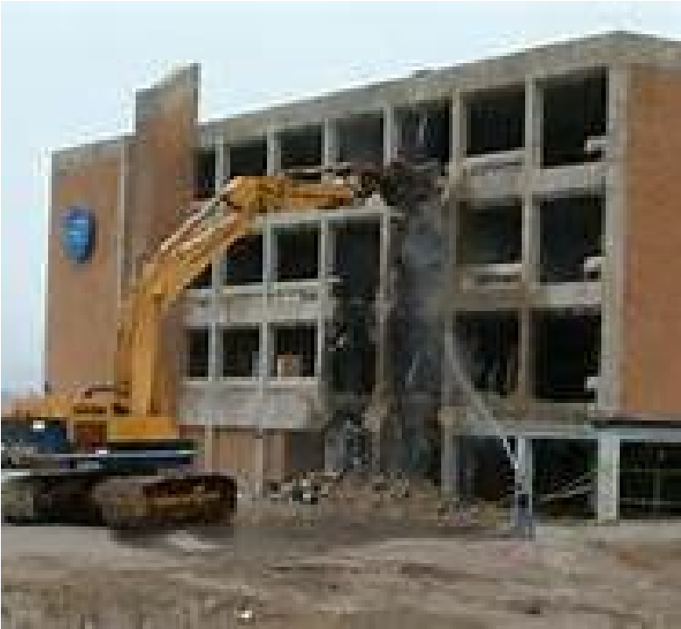
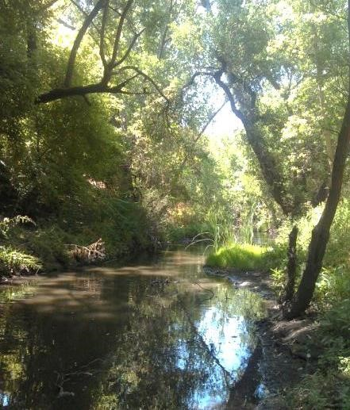
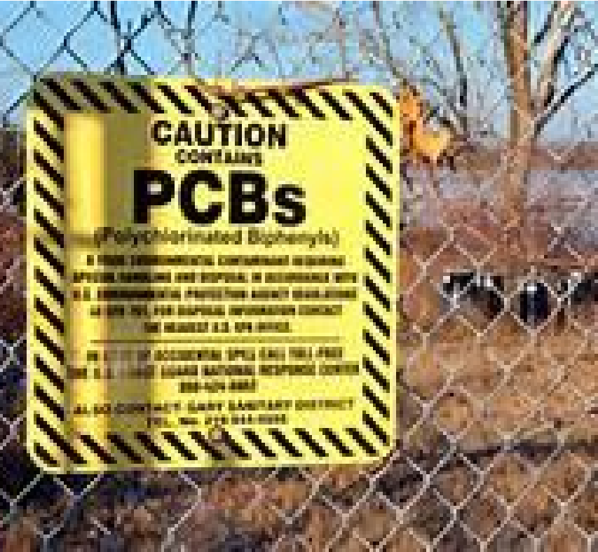

ADD PERMITTEE’S LOGO HERE

Polychlorinated Biphenyls (PCBs)
Screening Assessment Applicant Package
May 2019 (Revised December 2019)
Managing
PCBs-Containing Materials during Demolitions

Contents
Managing PCBs-Containing Materials during Demolitions
Disclaimer 1
Process Overview 2
PCBs Screening Assessment Flowchart 3
Application Instructions for Completing the PCBs Screening Assessment Form 4
Part 1. Owner and project information 4
Part 2. Is building subject to the screening requirement
based on type, use, age of the building? 4
Part 3. Report concentrations of PCBs in priority building materials 5
Part 4. Certification 6
PCBs Screening Assessment Form 7
Notice to Applicants 9
Agency Contacts 10
Consultant’s Report Template 11
QA/QC Checklist 13
Priority Building Material Applications Tables 14

Disclaimer
The material presented in this document is intended solely for the implementation of a municipal regulatory program required by the San Francisco Bay Area Regional Water Quality Control Board Municipal Regional Stormwater Permit for the protection of water quality under the Clean Water Act.
This document does not address other environmental programs or regulations (e.g., PCBs regulations under the Toxic Substances Control Act (TSCA); federal, state, or local regulations for hazardous material handling and hazardous waste disposal; health and safety practices to mitigate human exposure to PCBs or other hazardous materials; recycling mandates; and abatement at sites with PCBs (or other contaminants). The applicant is responsible for knowing and complying with all relevant laws and regulations.
Process Overview

This document describes a PCBs in Priority Building Materials Screening Assessment process to be conducted by demolition project proponents (applicants). A flow chart illustrating the above processes is provided (Page 3).
Water quality within the San Francisco Bay
Region is regulated by the San Francisco Bay Area Regional Water Quality Control Board (Regional Water Board).

In 2015, the Regional Water Board reissued the Municipal Regional Permit (MRP) that regulates discharges of stormwater runoff. The MRP includes provisions for reducing discharges of polychlorinated biphenyls (PCBs) in stormwater runoff and requires municipalities to develop a program to manage priority PCBs–containing building materials during demolition and implement the program by July 1, 2019.

Existing federal and state regulations create the framework for managing PCBs in building materials once those PCBs are identified through this program and for disposing of wastes containing PCBs.

Applicants proposing to demolish buildings must conduct the PCBs screening assessment. Through the PCBs screening assessment applicants will:
- Determine whether the building proposed for demolition is likely to have PCBs-containing building materials (see discussion of applicable structure); and
- Determine whether PCBs are present at a concentration equal to or greater than 50 parts per million (ppm) in building materials.
Use the PCBs Screening Assessment Form (page 7) to summarize and certify the information required by the municipality to issue the demolition permit. The form is divided into four parts:
- Part 1 provide applicant information and project location.
- Part 2 complete the questions to identify whether the project involves an applicable structure. If the demolition does not involve an applicable structure, the form may be certified and submitted without completing Part 3.
- Part 3 complete the questions to provide the concentrations of PCBs in any priority building materials.
- Part 4 certify the information being submitted.
Note that fluorescent light ballasts, polyurethane foam furniture, and Askarel fluid used in transformers, all of which may contain PCBs, are typically managed during pre-demolition activities under current regulations and programs that require removal of universal waste and outdated transformers. For this process it is assumed that those materials will be evaluated and managed under those existing programs.
This screening process is part of a program for water quality protection and was designed in accordance with requirements in the MRP. ¹ It does not address other environmental programs or regulations (e.g., PCBs regulations under the Toxic Substances Control Act (TSCA); federal, state, or local regulations for hazardous material handling and hazardous waste disposal; health and safety practices to mitigate human exposure to PCBs or other hazardous materials; recycling mandates; or abatement at sites with PCBs (or other contaminants). The applicant is responsible for complying with all relevant laws and regulations. See the Notices to Applicants section for important additional information.
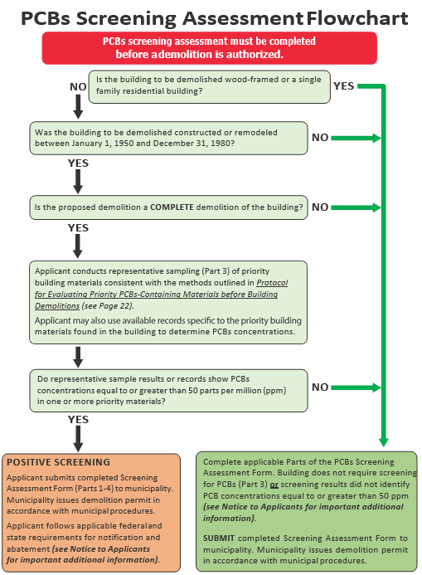
Applicant Instructions for Completing the PCBs Screening Assessment Form
Key Definitions

Demolition means the wrecking, razing, or tearing down of any building. The definition is intended to be consistent with the demolition activities undertaken by contractors with a C-21 Building Moving/Demolition Contractor’s License.

Priority Building Materials are:
- Caulk;
- Thermal insulation;
- Fiberglass insulation;
- Adhesive mastics; and
- Rubber window gaskets.

Buildings are structures with a roof and walls standing more or less permanently in one place. Buildings are intended for human habitation or occupancy.

Applicable Structures are defined as buildings constructed or remodeled between January 1, 1950 and December 31, 1980. Wood framed buildings and single-family residential buildings are not applicable structure regardless of the age of the building.

Applicants for demolition permits or other permits that involve the complete demolition of a building must conduct an assessment to screen for PCBs in priority building materials. Use the PCBs Screening Assessment Form, to summarize and certify the information needed by the municipality to issue a demolition permit. The form is provided beginning on page 7.
If the project includes the demolition of multiple buildings complete one form for each building to be demolished.
Part 1. Owner and project information
Complete the owner and consultant information and the project location information.
For the Type of Construction select one of the following options:
- Wood Frame (Buildings constructed with lumber or timbers, which make up the studs,
plates, joists, and rafters.)
- Masonry Construction (Buildings constructed with concrete blocks or bricks as the load bearing walls typically with the floors and ceilings constructed with wooden joists.)
- Steel Frame Construction (Buildings constructed with steel studs or steel columns and steel joists or trusses to support floors and roofs. Includes light gauge steel construction and high-rise steel construction.)
- Concrete Frame (Buildings constructed with reinforced concrete columns, concrete beams, and concrete slabs.)
- Pre-Engineered (Buildings constructed with pre-engineered parts bolted together.)

Part 2. Is building subject to the screening requirement based on type, use, and age of the building?
Part 2 documents the determination of whether the proposed demolition will affect an applicable structure. If the demolition does not affect an applicable structure, then the assessment is complete, and the form can be certified.
This determination screens out buildings that are a lower priority with regard PCBs-containing materials and provides an off-ramp from the rest of the screening process.
Question 2.a: Is the building to be demolished wood framed and/or single family residential?
- If YES the PCBs Screening Assessment is complete, skip to the certification in Part 4.
- If NO, continue to Question 2.b.
Question 2.b: Was the building to be demolished constructed or remodeled between January 1, 1950 and December 31, 1980?
- If YES continue to Question 2.c.
- If NO, the PCBs Screening Assessment is complete, skip to the certification in Part 4.
Studies have found the highest concentrations of PCBs in building materials in buildings that were built or remodeled from 1950 to 1980.

For this process, the date that the building permit was issued will be used to determine applicability.

Question 2.c: Is the proposed demolition a complete demolition of the building (as defined in key definitions of this document)?
- If YES continue to Part 3.
- If NO, the PCBs Screening Assessment is complete, skip to the certification in Part 4.

Part 3. Report concentrations of PCBs in priority building materials
Part 3 documents the results of the assessment of PCBs concentrations in priority building materials. Part 3 is only required for proposed demolition of an applicable structure, as determined in Part 2. Check the option used.
- Option 1 Conduct representative sampling and analysis of the priority building materials per BASMAA’s Protocol for Evaluating Priority PCBs-Containing Materials before Building Demolition (dated August 2018) (hereinafter referred to as the Protocol).
- Option 2 Use existing building records for the priority building materials. Applicants who have conducted sampling prior to the publication of the Protocol may use that data provided it is consistent with the Protocol (e.g., analytical methods, sample collection frequency, QA/QC). It is anticipated that prior sampling results will rarely be available and that most Applicants will need to use Option 1.
3.a Option 1 – Conduct representative sampling
Check this box if you conducted representative sampling and analysis of the priority building materials per the Protocol.
- Complete the applicable tables for each priority building material.
- Attach the consultant’s report documenting the evaluation results.
- Attach (or include in the consultant’s report) the QA/QC checklist (see Protocol, Section 3.2.4).
- Attach copies of the analytical data reports.
3.a Option 2 – Use existing building records
In some cases, a property owner may have conducted sampling of the priority building materials for PCBs. If such data exist, you may use these data to demonstrate the concentration of PCBs in the priority building materials for the PCBs screening. However, if the sampling must be consistent with the Protocol.
- Complete the applicable tables for each priority building material.
- Attach the consultant’s report/statement that the results are consistent with the Protocol.
- Attach copies of the analytical data reports.
Part 3 Tables Summarize concentrations of PCBs in priority building materials
Use these tables to summarize the concentrations of PCBs in the priority building materials.
- Each page of the table is for a different material. Duplicate the pages as needed to report all concentration data.
- A blank page is provided. Applicants have the option of submitting PCBs concentration data on other materials in addition to the priority building materials.
Column 1: required for all priority building material PCBs concentrations
- Use column 1 to report all PCBs concentrations in the priority building materials. Provide short description of the sample location and concentration.

Column 2: only required for PCBs concentrations ≥50 ppm
- Use column 2 to estimate the amount of material associated with each sample.

Part 4. Certification
➢ Complete the certification. The certification must be signed by the property owner or the owner’s agent or legal representatives and the consultant who complete the application form.

For Municipality Use Only
Date Received
File #

PCBs Screening Assessment Form

This screening process is part of a program for water quality protection and was designed in accordance with requirements in the Bay Area regional municipal stormwater NPDES permit (referred to as the Municipal Regional Permit). This process does not address other environmental programs or regulations (e.g., PCBs regulations under the Toxic Substances Control Act (TSCA); federal, state, or local regulations for hazardous material handling and hazardous waste disposal; health and safety practices to mitigate human exposure to PCBs or other hazardous materials; recycling mandates; or abatement at sites with PCBs or other contaminants). The applicant is responsible for knowing and complying with all relevant laws and regulations. See Notices to Applicants section in the Applicant Instructions and at the end of this form.
Complete all applicable parts of the PCBs Screening Assessment Form and submit with your demolition permit application.

All Applicants must complete Part 1, Part 2, and Part 4.
Part 1. Owner/Consultant and project information
Owner Information
Name
Address
City | State | Zip
Contact (Agent)
Phone | Email
Consultant Information
Firm Name
Address
City | State | Zip
Contact Person
Phone | Email
Project Location
Address
City | State CA | Zip
APN (s)
Year Building was Built | Type of Construction
Estimated Demolition Date

Part 2. Is building subject to the PCBs screening requirement based on type, use, and age of the building?
2.a Is the building to be demolished wood framed and/or single family residential? | Yes | No
If the answer to Questions 2.a is Yes, the PCBs Screening Assessment is complete, skip to Part 4.
If the answer is No, continue to Question 2.b.
2.b Was the building to be demolished constructed or remodeled between January 1,  1950 and December 31, 1980? | Yes | No
If the answer to Questions 2.b is No, the PCBs Screening Assessment is complete, skip to Part 4.
If the answer is Yes, continue to Question 2.c.
2.c Is the proposed demolition a complete demolition of the building? | Yes | No
If the answer to Questions 2.c is No, the PCBs Screening Assessment is complete, skip to Part 4.
If the answer is Yes, complete Part 3.

All applications affecting applicable structures and demolitions must complete Part 3 and provide required supporting documents.
Part 3. Report concentrations of PCBs in priority building materials
Option 1. Applicants conducted representative sampling and analysis of the priority building materials per the Protocol for Evaluating Priority PCBs-Containing Materials before Building Demolition (BASMAA, August 2018).
Option 2. Applicants possess existing sample results that are that are consistent with the Protocol for Evaluating Priority PCBs-Containing Materials before Building Demolition.
3.a Select option and report PCBs concentrations in the priority building materials and the source of data for each of the priority building materials. Provide the required supporting information
Option 1 Conduct Representative Sampling  - Summarize results on Part 3 Tables; and  - Provide the following supporting information:  - Consultant’s report documenting the assessment results;  - QA/QC checklist (see page 13); and  - Copies of the analytical data reports.  (Part 3 Tables begin on p.14 of the applicant package) | Option 2 Use Existing Building Records  - Summarize results on Part 3 Tables; and  - Provide the following supporting information:  - Consultant’s report/statement that the results are consistent with the Protocol for Evaluating Priority PCBs-Containing Materials before Building Demolitions  - Copies of the analytical data reports.
All Applicants must complete Part 4.
Part 4. Certification
I certify that the information provided in this form is, to the best of my knowledge and belief, true, accurate, and complete. I further certify that I understand my responsibility for knowing and complying with all relevant laws and regulations related to reporting, abating, and handing and disposing of PCBs materials and wastes. I understand there are significant penalties for submitting false information. I will retain a copy of this form and the supporting documentation for at least 5 years.

Signature: Date:
(Property Owner//Agent/Legal Representative)

Print/Type:
(Property Owner/Agent/Legal Representative Name)
Signature: Date:
(Consultant Completing Application Form)

Print/Type:
(Consultant Completing Application Form)

Notices to Applicants Regarding Federal and State PCBs Regulations

Applicants that determine PCBs exist in priority building materials must follow applicable federal and state laws. This may include reporting to U.S. Environmental Protection Agency (USEPA), the San Francisco Bay Regional Water Quality Control Board, and the California Department of Toxic Substances Control (DTSC). These agencies may require additional sampling and abatement of PCBs.
Depending on the approach for sampling and removing building materials containing PCBs, you may need to notify or seek advance approval from USEPA before building demolition. Even in circumstances where advance notification to or approval from USEPA is not required before the demolition activity, the disposal of PCBs waste is regulated under Toxic Substances Control Act (TSCA).
Additionally, the disposal of PCBs waste is subject to California Code of Regulations (CCR) California Code of Regulations (CCR) Title 22, Section Division 4.5, Chapter 12, Standards Applicable to Hazardous Waste Generators.
Building owners and employers need to consider worker and public safety during work involving hazardous materials and wastes including PCBs.

Federal and State Regulations
See 40 Code of Federal Regulations (CFR) 761.3 for important information relative to disposal of PCBs-containing building materials, including definitions of PCBs bulk product wastes and PCBs remediation wastes. Also see the memorandum dated October 24, 2012 “PCB Bulk Product Waste Reinterpretation” from Suzanne Rudzinski, Director, Office of Resource Conservation and Recovery, EPA.

Disposal of PCBs wastes are subject to TSCA requirements such as manifesting of the waste for transportation and disposal. See 40 CFR 761 and 40 CFR 761, Subpart K.

TSCA-regulated does not equate solely to materials containing PCBs at or above 50 ppm. There are circumstances in which materials containing PCBs below 50 ppm are subject to regulation under TSCA. See 40 CFR 761.61(a)(5)(i)(B)(2)(ii).

Disposal of PCBs wastes are subject to California Code of Regulations (CCR) Title 22, Section Division 4.5, Chapter 12, Standards Applicable to Hazardous Waste Generators.

California hazardous waste regulatory levels for PCBs are 5 ppm based on the Soluble Threshold Limit Concentration test and 50 ppm based on the Total Threshold Limit Concentration test, see CCR, Title 22, Section 66261.24, Table III.

Agency Contacts

Applicants should contact the appropriate agencies and review the relevant guidance and information about PCBs in building materials. Municipal staff are not able to advise you on the requirements of the applicable federal and state laws.

Agency | Contact | Useful Links
US Environmental Protection Agency | Steve Armann (415) 972-3352 armann.steve@epa.gov | https://www.epa.gov/pcbs (EPA PCB website)  https://www.epa.gov/pcbs/questions-and-answers-about-polychlorinated-biphenyls-pcbs-building-materials (PCBs in Building Materials Fact Sheet and Q/A Document)  https://www.epa.gov/pcbs/pcb-facility-approval-streamlining-toolbox-fast-streamlining-cleanup-approval-process (USEPA PCB Facility Approval Streamlining Toolbox (PCB FAST))  https://www.epa.gov/pcbs/polychlorinated-biphenyls-pcbs-building-materials#Test-Methods (See Information for Contractors Working in Older Buildings that May Contain PCBs)
San Francisco Bay Regional Water Quality Control Board | Jan O’Hara (510) 622-5681  Janet.O’Hara@waterboards.ca.gov  Cheryl Prowell (510) 622-2408  Cheryl.Prowell@waterboards.ca.gov | https://www.waterboards.ca.gov/sanfranciscobay/water_issues/programs/TMDLs/sfbaypcbstmdl.shtml  https://www.waterboards.ca.gov/sanfranciscobay/water_issues/programs/sitecleanupprogram.html
Department of Toxic Substances Control | Regulatory Assistance Office  1-800-72TOXIC  RAO@dtsc.ca.gov | http://www.dtsc.ca.gov/SiteCleanup/Brownfields/upload/PUB_SMP_Guide-to-Selecting-a-Consultant.pdf
California Division of Occupational Safety and Health (known as Cal/OSHA) | CalOSHA Consultations Services  1-800-963-9424 | https://www.dir.ca.gov/dosh/consultation.html

Template for Consultant’s Report from Pre-demolition PCBs Building Survey
(page 1 of 2)

Demolition Site Information
Brief description of building, including construction type (e.g., concrete frame, masonry, steel frame, pre-engineered):
Address
City | State | Zip
Date(s) that the PCBs building survey was conducted:
Consultant Information
Firm Name
Address
City | State | Zip
Contact Person
Telephone | Email
Consultant’s Demolition Site Contact (e.g., property owner, project proponent, or agent)
Name
Telephone | Email
Certified Analytical Laboratory Information
Name
Address
City | State | Zip

Template for Consultant’s Report from Pre-demolition PCBs Building Survey
(page 2 of 2)

Describe the survey methods, including:
- Sampling procedures
- Number of samples collected
- Sample identification numbers
- Types of materials sampled (attach example photographs for each material type)
- Descriptions of sample locations (attach maps)

Provide a summary of the testing results, including:
- PCBs concentration in each sample of priority building material that was collected.
- Estimated amount of material (in linear feet for caulking or rubber window gaskets, or square feet for mastics/adhesives or insulation) associated with each sample with a PCBs concentration ≥ 50 ppm (note: this information is needed to complete the Part 3 Tables beginning on page 14 of the Applicant Package):

Check boxes to indicate that the following documents are attached:
- Analytical laboratory reports
- QA/QC checklist (page 13 of the Applicant Package)

QA/QC Checklist
For this program, general quality assurance and quality control (QA/QC) procedures will be utilized. The following checklist should be used by the consultant performing the evaluation:
- Proper specified sampling equipment was used (pre-cleaned or other, stainless steel);
- Proper decontamination procedures were followed;
- Sampling collection spatial frequency was met;
- A National Environmental Laboratory Accreditation Program (NELAP) laboratory was utilized;
- Samples were received by the laboratory within proper temperature range;
- Samples were extracted and analyzed within the method holding time for EPA Method 8082/8082A; and
- Sample reporting limit met data quality objectives.

Part 3. Priority Building Material Applications Table: Caulk
Column 1. Report all PCBs concentrations for each homogeneous area of caulking area (see Page 31 of Protocol, Section 2.2.2). Use sample designators/descriptions from laboratory report. |  | Column 2. Complete for each concentration ≥ 50 ppm
Caulk Application Sample Description | Concentration (mg/kg) | Estimate Amount of Material (in Linear Feet)
Example: Caulk Sample 1 | 320 | 48

Duplicate page if additional space is needed.

Part 3. Priority Building Material Applications Table: Fiberglass Insulation
Column 1. Report all PCBs concentrations for each homogeneous area of caulking area (see Page 31 of Protocol, Section 2.2.2). Use sample designators/descriptions from laboratory report. |  | Column 2. Complete for each concentration ≥ 50 mg/kg
Fiberglass Insulation Application  Sample Description | Concentration (mg/kg) | Estimate Amount of Material (in Square Feet)
Example: Fiberglass Insulation Sample 1 | 78 | 86

The area of insulation wrapped around a pipe may be estimated using the following formula:
Area (square feet) = 2πrh; where r is the pipe radius (feet) and h is the pipe length (feet).

Duplicate page if additional space is needed.
Part 3. Priority Building Material Applications Table: Thermal Insulation
Column 1. Report all PCBs concentrations for each homogeneous area of caulking area (see Page 31 of Protocol, Section 2.2.2). Use sample designators/descriptions from laboratory report. |  | Column 2. Complete for each concentration ≥ 50 mg/kg
Thermal Insulation Application  Sample Description | Concentration (mg/kg) | Estimate Amount of Material (in Square Feet)
Example: Thermal Insulation Sample 1 | 20

The area of insulation wrapped around a pipe may be estimated using the following formula:
Area (square feet) = 2Πrh; where r is the pipe radius (feet) and h is the pipe length (feet).

Duplicate page if additional space is needed.
Part 3. Priority Building Material Applications Table: Adhesive Mastic Insulation
Column 1. Report all PCBs concentrations for each homogeneous area of caulking area (see Page 31 of Protocol, Section 2.2.2). Use sample designators/descriptions from laboratory report. |  | Column 2. Complete for each concentration ≥ 50 mg/kg
Adhesive Mastic Insulation Application  Sample Description | Concentration (mg/kg) | Estimate Amount of Material (in Square Feet)
Example: Adhesive Mastic Insulation Sample 1 | 87.4 | 800

Duplicate page if additional space is needed.

Part 3. Priority Building Material Applications Table: Rubber Window Gasket
Column 1. Report all PCBs concentrations for each homogeneous area of caulking area (see Page 31 of Protocol, Section 2.2.2). Use sample designators/descriptions from laboratory report. |  | Column 2. Complete for each concentration ≥ 50 mg/kg
Rubber Window Gasket Application  Sample Description | Concentration (mg/kg) | Estimate Amount of Material (in Linear Feet)
Example: Window Gasket Insulation Sample 1 | 70 | 75

Duplicate page if additional space is needed.

Part 3. Priority Building Materials Table: Other
Column 1. Optional: Use this form to report PCBs concentration data from materials other than priority building materials. Report PCBs concentrations for each material and homogeneous area. Use sample designators/descriptions from laboratory report. |  | Column 2. Complete for each concentration ≥ 50 mg/kg
Material Sample Description | Concentration (mg/kg) | Estimate Amount of Material (units vary)
Example: Wall paint Sample 1 | 228 | 1500 Square Feet

Duplicate page if additional space is needed.

A National Pollutant Discharge Elimination System (NPDES) permit, Order No. R2-2015-0049, issued to municipalities in the counties of Alameda, Contra Costa, San Mateo, and Santa Clara, and the Cities of Fairfield, Suisun City, and Vallejo.
The consultant’s report of the findings of the PCBs building material evaluation. See section 3 of the Protocol.

